# Exercise 7 Perceptron and ACO

## Task 1

1. What is pheromone? What is it’s purpose?
2. An Ant is in A and can go to the B, C, D, E. Pheromone level on the trail and the distance is set to (F, D)

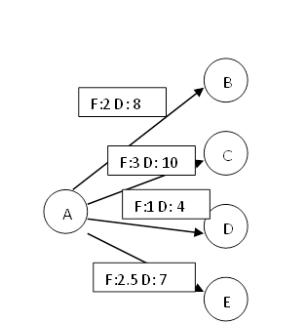

* 1. Which path will the Ant pick?
  2. What will be the level of the pheromone trail after Ant has passed? You assume that α = β = 0.9 ρ = 0.9 Q = 10
  3. What impact has the value of α and β on the trail the election?

## Task 2

You are going to program a simple perceptron. Afterwards you will train the perceptron. You will feed the perceptron with a training set of data and the perceptron should learn to determine which class the different data belongs to. Afterwards you will run the perceptron with a new data set to test the performance of the perceptron.

The training set is divided into two sets, Category 1 and Category 2. Each category consist of a set of points, (x,y) ε Category.

Training set:

Category 1 consists of the following points:

(-10,5) (-10,18) (-9,20) (-5,5) (-3,0) (2,-3) (5,-7) (5,-8)

Category 2 consists of the following points:

(5,-6) (5, 0) (4,0) (1,0) (1,1) (-2,5) (-3,11) (-6, 18) (-10,24)

The test set will not be used to change the weights of the perceptron. Its purpose is merely to test the performance of the perceptron.

Test set:

Category 1 consists of the following points:

(-8,4) (-6,12) (-5,6) (-5,10) (0,2) (1,0) (6,-12) (6,-14)

Category 2 consists of the following points:

(-7,18) (-9, 30) (-5,8) (-1,14) (1,4) (2,0) (2,11) (3, 0) (6,-5)

1. How will the perceptron look like? Draw a diagram and explain
2. Program the perceptron and train it. Demonstrate it for your co-students.
3. How many training cycles do you need to minimize the error for both training set and test set?
4. How small is the error that you obtain? Compare with the efforts of other students.
5. The perceptron defines a hyperplane in the two-dimensional space. Suggest a mathematical function for this hyperplane. Test your hypothesis by means of a regression. For this purpose you can use MS Excel.
6. What are the major differences between the perceptron that you have created and a feed forward back propagation network?

Answer the questions and document the performance of your system with screen shots. Upload you Python file with your program in addition to the answers here.